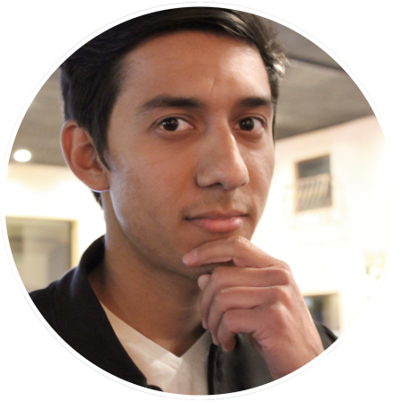
LLOYD GARCIA
3D ENVIRONMENT ARTIST
LLOYDGARCIA.WEEBLY.COM
LLOYD_G_@HOTMAIL.COM
951.534.8631

WORK EXPERIENCE
FREELANCE WORK 2D/3D Designs
3D Artist/Graphic Design -Created 2D digital illustrations for shirts, posters and invitation/greeting cards
September 2016 - Present -Responsible for creating 2D and 3D logos for clients
-Created 3D mock ups for wedding/school ceremonies
-Worked with clients to create desired tattoo design
-Animated 2D Flash designs for client websites
LEGEND 3D, Inc. 3D FILMS
Stereo Conversion Artist Legend 3D is an innovative stereoscopic and visual effects company. During my time here
February 2014 - February 2015 I worked on feature films such as The Amazing Spider-man 2, The Walk, Jupiter Ascending,
Poltergeist and Insurgent (The Divergent Series).
-Self-prioritized large queue of work
-Responsible for converting 2D images to stereoscopic 3D
-Learned how to use and work with their patented proprietary 3D software
-Worked and collaborated with the Lead Stereo Conversion Artist,
Production Coordinator, and Stereo Supervisor to ensure efficient shot production
-Participated in and completed additional tasks/special
projects assigned by the Lead Stereo Conversion Artist
FIRST CONTACT 3D ANIMATED SHORT
Lead Texture Artist A student 3D animated short created within a span of 22 weeks with a small group of artist.
January 2013 - June 2013 -Modeled, unwrapped and textured several props/environments
-Unwrapped and textured the antagonist
-Set dressed, rendered and composited scenes in post production
-Animated several dynamic scenes
SWEET REVENGE 2D FLASH ANIMATED SHORT
Character Designer This short was created at The Art Institute of the Inland Empire as a group project.
October 2012 - December 2012 -Designed several characters and initial concept of story
-Provided voice for an essential character
-Animated multiple key shots
-Created 2D assets for characters
VICTORIA'S SECRET
Sales and Support Associate/Beauty Consultant
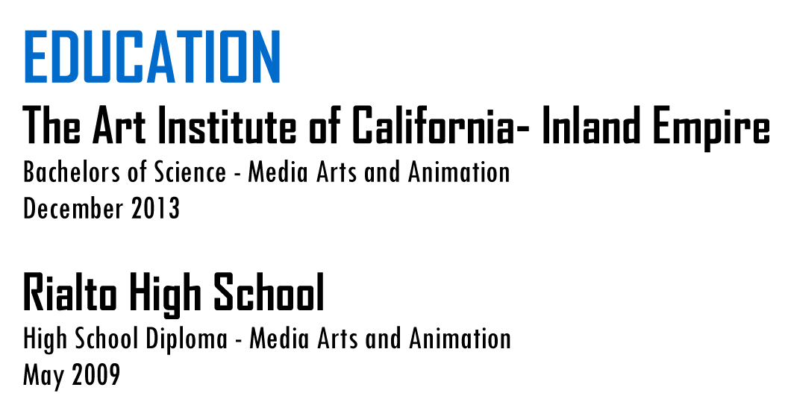
May 2015 - Present
SKILLS
SOFTWARE
Autodesk Maya, Photoshop, Illustrator, After Effects, Premiere Pro,
Zbrush, Mental Ray, SketchUp, Crazy Bump, Keyshot, Audition

TECHNICAL SKILLS
3D Modeling, Unwrapping, Texturing (Bump, Normal, and Specular),
Lighting, Rendering, Compositing, Digital Painting, Animation,
Motion Graphics, Basic Rigging, Sculpting

